Joseph, Polly Knights in the D & C Ancestors YouTube Historic Knight Family Books about Connecting
#1
& Posterity Colesville stories Family Sites Reunions Knights Generations
The Posterity of Joseph Knight, Sr. and Polly Peck Knight

Click on an individual to see stories, photos, and articles
Joseph Sr.
dates
Polly Peck
Dates

Child 2
Esther
Child 1 Nahum
Child 4
Anna
Child 5
Joseph, Jr.
Child 7
Elizabeth
Child 6
Polly
Child 3 Newel

married to Thankful married Wm. Married Sally Colburn, married Freeborn md. Betsey Covert married Joseph J. married Wm Stringham
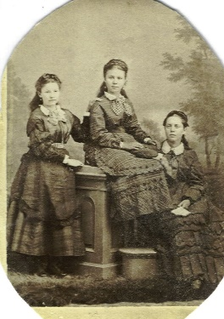
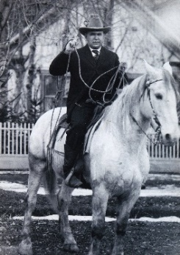
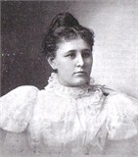
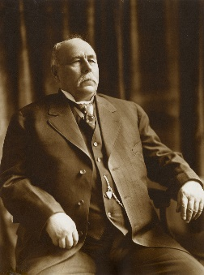
Lydia Goldthwaite DeMill
Ether #8
Joseph Knight
Sr.
Read about some of Joseph and Polly’s amazing grandchildren and great-grandchildren.
Click on a name.

Jesse Knight, mining magnate and philanthropist
Goodwin Knight, a governor of California
Inez Knight, first sister missionary for the LDS Church
Richard Knight, Nahum’s son found
Charlotte Knight, a foreign war correspondent in Korea
Ray Knight, co-founder of Raymond, Canada and
the Calgary Stampede

Mary Elizabeth Knight – A young girl who helped in the Battle of Nauvoo

Lydia Knight Young – pioneer in the Mexican colonies

Charles #9
Phebe Crosby Peck person
2nd wife
md. Jane Terry
Click here to see factoids about Knight Family
members

